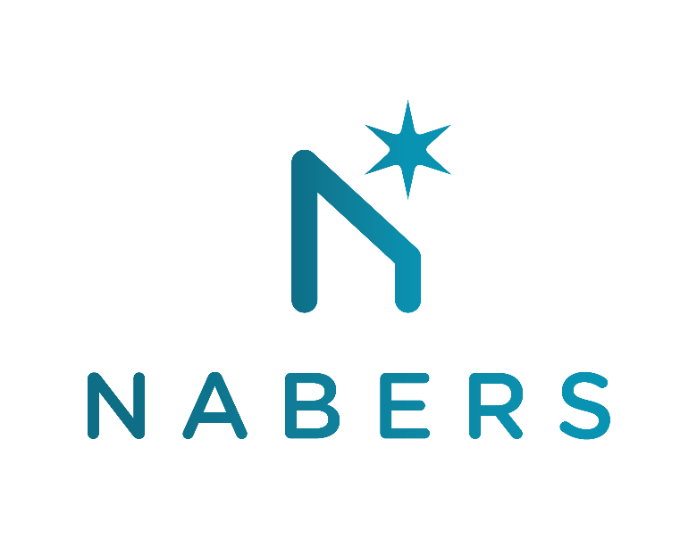

Future of NABERS Energy
Consultation response form

Thank you for responding to the Future of NABERS Energy consultation.
Please provide your feedback in this document, and return in word (.docx) format to nabers@environment.nsw.gov.au.
Please return your responses by COB Friday 12th June 2020.

NABERS is administered by the NSW Department of Planning, Industry and Environment
Organisation: Enter your organisation’s name here

Section | Question | Comments
Section 2 Update to emissions factors used in NABERS | - Do you have any comments on the planned update to the emissions factors (section 2.3)? | Enter your responses to the questions in this table
 | - Do you have any feedback on the proposed implementation and update timelines (section 2.4)?
 | - Do you think that the prediction tool will be of value to industry? Do you have any other feedback on the prediction tool?
 | - Do you have any other suggestions of how we can prepare industry for this change?
Section 3  NABERS Net Zero Emissions | - Are you in favour of the development of a NABERS Net Zero Emissions certification?  Would you use it or recommend it?
 | - Do you think that the name NABERS Net Zero emissions is suitable for the certification?
 | - Do you agree that the proposed boundary for net zero recognition should be identical to NABERS Energy with GreenPower (stationary energy)?
 | - Do you support NABERS’ proposal to expand its offset mechanisms from recognising renewable electricity only, to also include certified zero-carbon fuels?
 | - Should a minimum NABERS Energy rating (without Greenpower) be required to achieve NABERS net zero certification (e.g. the star rating of the 50th percentile, such as 4 stars for offices)?
 | - Are there any other fuel types that you expect to be used in buildings in the short to medium term future?
Section 4  NABERS Energy with GreenPower | - Do you agree that the NABERS Energy with GreenPower tool should be maintained, (option 1)?
 | - If you agree with Option 1, should the name be changed (option 1b)? If so, what name would you suggest?
 | - What other risks and issues should NABERS consider in making this decision?
Section 5  Market-based carbon accounting | - Are you in favour of the proposed changes?
 | - Do you have any other feedback on the proposed changes?
Section 6  Renewable Energy purchasing | - Would you be likely to use non-GreenPower LGCs for a NABERS Energy with GreenPower rating or to achieve the NABERS Net Zero Emissions badge if it became possible?
 | - What are your views on NABERS’ suggestion to accept only Wind and Solar LGCs?
- Do you have any feedback on the proposed process for verifying and auditing LGCs?
Would the additional costs of this process be acceptable?
 | - Do you have any other feedback on this issue?

If you have any other feedback or context related to this consultation that you would like to provide, please add it here:

